Marine Sensitivity

Project Documentation

Ben Best

2024-09-19

Table of contents

# Preface

This is a Quarto book.

# 1. Introduction

This Marine Sensitivity (MS) project of [BOEM](https://boem.gov) seeks to assess the sensitivity of marine species to offshore energy development, whether oil & gas or wind. By combining the best available species distributions with known species sensitivities we can map out areas of the ocean that are most vulnerable to human activities. This information can be used to inform decisions about where to place energy infrastructure and/or implement mitigations to minimize impacts on the marine environment.

This is a process, not a product. Information is imperfect, especially given the large expanse of US waters. Distributions and abundance of species change, modified increasingly by climate change and human activities. Knowledge on species sensitivities continues to expand with more research. And finally the methods for both modeling and distributing all this information continue to improve. We aim to provide a transparent and reproducible process that can be regularly updated as new data and methods become available.

|  |
| --- |
| Figure 1.1: Flowchart of process for incorporating marine species sensitivities with distributions and generating a holistic vulnerability map. |

# 2. Science

The term vulnerability ($V$) is a function of exposure ($E$), sensitivity ($S$) and adaptive capacity () (Equation 2.1).

$$V=f\left(E,S,A\right) \left(2.1\right)$$

|  |
| --- |
| Figure 2.1: Overview of process. |



The raster of vulnerability ($V$) contains cells representing a sum across species ($spp$) of presence ($p$) multiplied by the sensitivity weight () (Equation 2.2).

# 3. Stressors

## 3.1 Offshore Wind Energy

Evaluation of stressors from the offshore wind industry needs to be evaluated based on human activities given the phase of development, whether pre-construction, construction, operation or decommissioning (Figure 3.1).

|  |
| --- |
| Figure 3.1: Cumulative adverse effects of offshore wind energy development on wildlife (Goodale and Milman 2016). |

## 3.2 Oil & Gas

# 4. Receptors

Receptors are the species and habitats that are potentially impacted by the human activity.

## 4.1 Species

### 4.1.1 Corals

### 4.1.2 Invertebrates

### 4.1.3 Fish

### 4.1.4 Marine Mammals

### 4.1.5 Seabirds

### 4.1.6 Sea Turtles

## 4.2 Habitats

### 4.2.1 Coral Reefs

### 4.2.2 Hydrothermal Vents

### 4.2.3 Kelp Forests

### 4.2.4 Mangrove Forests

### 4.2.5 Seamounts

## 4.3 Primary Productivity

# 5. Exposure

Cumulative exposure (Figure 3.1) is important for understanding impacts to a population.

# 6. Software

### 6.0.1 Interactive Applications

We have developed a series of interactive applications to explore the data and results of the MS project. These applications allow users to visualize the data, explore the results, and interact with the data in a more intuitive way. The applications are built using the [shiny](https://shiny.posit.co) package in R, which allows us to easily create a user interface with complex reactivity for an interactive web application easily accessed through a web browser. The applications are designed to be user-friendly and intuitive, with interactive maps, charts, and tables that allow users to explore the data in a more dynamic way.

### 6.0.2 Overcoming Challenges with Large Spatial Data

The MS project incorporates many large spatial datasets that are problematic to render in a typical interactive application. For instance, the most common interactive mapping R package leaflet has a 4MB limitation for displaying rasters (see “Large Raster Warning” in [Raster Images • leaflet](https://rstudio.github.io/leaflet/articles/raster.html#large-raster-warning)). Vectors (i.e., points, lines and polygons) get smoothed when containing many vertices, but contiguity gets lost between polygons and rendering degrades to non-usable depending on the internet speed of the user’s connection.

To work around these limitations, we have implemented “cloud native” web services and formats (see also [Cloud-Optimized Geospatial Formats Guide](https://guide.cloudnativegeo.org/)). Our implementations effectively reduce the size of any given spatial object based on the zoom level of the user’s browser. For rasters, we use cloud-optimized GeoTIFFs (COGs) and for vectors, we use Mapbox Vector Tiles (MVT). These formats are designed to be fast and efficient for web mapping applications, and they allow us to display large spatial datasets in an interactive web application without sacrificing performance or usability. Let’s take a closer look at implementation of each.

#### 6.0.2.1 Raster: Cloud-Optimized GeoTIFFs (**COGs**) and **Titiler**

Historically, to read a raster, such as a GeoTIFF, from the web, the client software would have to read the entire file before rendering. Cloud Optimized GeoTIFFs ([COGs](https://www.cogeo.org)) take advantage of [HTTP GET range requests](https://tools.ietf.org/html/rfc7233) to read only the part of the file needed for rendering. So a COG stores quadtree simplifications of the original raster at multiple zoom levels and metadata for accessing their byte ranges in the file in the metadata header. This allows the client software to request only the parts of the file needed for rendering, which can greatly reduce the amount of data transferred and speed up rendering. This is for accessing the raw data in pixel values, e.g., for a raster of species distribution then the abundance of a species in each cell. We would want to also apply a color ramp to visualize the data. The open-source ([TiTiler](https://developmentseed.org/titiler/) software is a lightweight web service that serves up these color ramped tiles on the fly. So COGs can be stored on a simple file server (like Amazon S3 or Azure Blob Storage) and served up as interactive web maps with TiTiler as an intermediary between the COG files and the client accessing the interactive Shiny mapping app (Figure 6.1).

|  |
| --- |
| Figure 6.1: Sequence diagram implementing large raster interactive display using Cloud-Optimized GeoTIFFs (COGs) and Titiler in a Shiny mapping app. |

#### 6.0.2.2 Vector: Mapbox Vector Tiles (**MVTs**) and **pg_tileserv**

Although “cloud native” vector formats exist for simple file storage (see [Cloud-Optimized Geospatial Formats Guide](https://guide.cloudnativegeo.org/)), none of these allow for flexible filtering and manipulation. Instead, we use PostgreSQL with the spatial extension ([PostGIS](https://postgis.net)) to store the vector data and serve it as Mapbox Vector Tiles ([MVTs](https://docs.mapbox.com/vector-tiles/specification/)) using the [**pg_tileserv**](https://github.com/CrunchyData/pg_tileserv) web service written in the language Go, which is very fast. This means that we don’t have to pre-render the MVTs (such as you might do with [tippecanoe](https://github.com/mapbox/tippecanoe)), but can instead serve the raw vector data directly from the database and let **pg_tileserv** handle the rendering on the fly. Filters (in the form of [CQL](https://github.com/CrunchyData/pg_tileserv/blob/master/hugo/content/usage/cql.md)) can be applied to the request. Symbology is rendered client-side via JavaScript, which allows for interactive hover and click events on vector objects (e.g., BOEM aliquot). Some speed-up is enabled by implementing a [Varnish](https://varnish-cache.org) cache service in between. We can even write our own database functions for customized rendering, such as H3 hexagonal summaries. This allows us to serve vector data as web maps with minimal configuration and setup, and it provides a fast and efficient way to display large vector datasets in an interactive web application (Figure 6.2).

|  |
| --- |
| Figure 6.2: Sequence diagram implementing large vector interactive display using Mapbox Vector Tiles (MVTs) and pg_tileserv in a Shiny mapping app. |

### 6.0.3 Github Repositories

| repo | description |
| --- | --- |
| [api](https://github.com/MarineSensitivity/api) | application programming interface (API) using R Plumber package |
| [apps](https://github.com/MarineSensitivity/apps) | Shiny applications |
| [docs](https://github.com/MarineSensitivity/docs) | documentation for BOEM’s offshore environmental sensitivity index products |
| [manuscripts](https://github.com/MarineSensitivity/manuscripts) | Manuscripts with review of sensitivities by industry and receptors (species, habitats, human uses) |
| [MarineSensitivity.github.io](https://github.com/MarineSensitivity/MarineSensitivity.github.io) | default website |
| [msens](https://github.com/MarineSensitivity/msens) | R library of functions for mapping marine sensitivities, sponsored by BOEM |
| [objectives](https://github.com/MarineSensitivity/objectives) | repository for issues spanning multiple repositories and doing big picture roadmapping |
| [server](https://github.com/MarineSensitivity/server) | server setup for R Shiny apps, RStudio IDE, R Plumber API, PostGIS database, pg_tileserv |
| [workflows](https://github.com/MarineSensitivity/workflows) | scripts for testing data analytics and visualization as well as production workflows |

### 6.0.4 Software Components

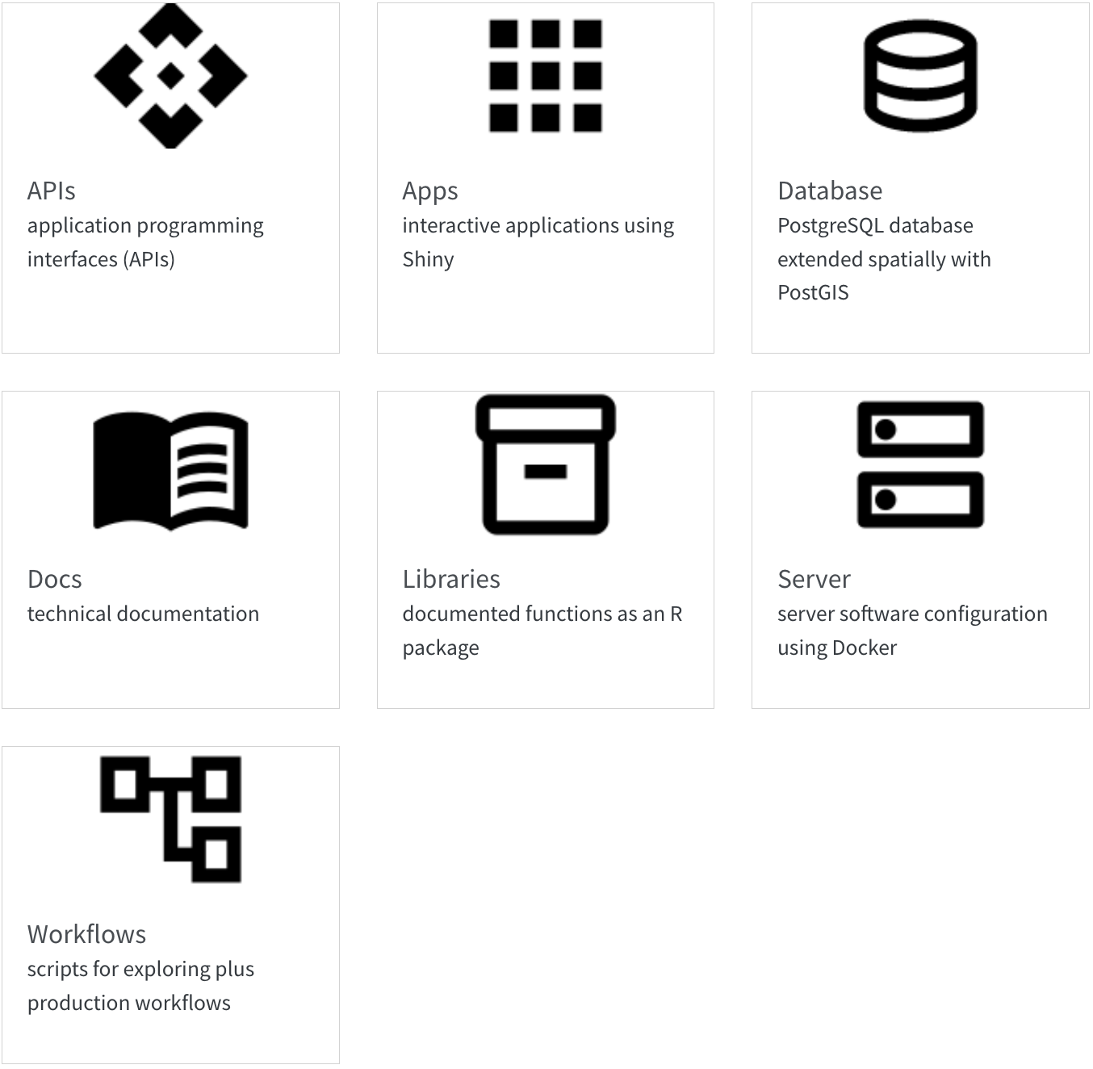

# 7. Server

The server is for serving up any web services outside those of Github (e.g., [website](https://marinesensitivity.org/), [docs](https://marinesensitivity.org/docs) and R package [msens](https://marinesensitivity.org/msens)) using [Docker](https://www.docker.com/) (see the [docker-compose.yml](https://github.com/MarineSensitivity/server/blob/main/docker-compose.yml); with reverse proxying from subdomains to ports by [Caddy](https://caddyserver.com)).

## 7.1 Setup

For instructions on launching an Amazon instance and installing the server software, see [Server Setup · MarineSensitivity/server Wiki](https://github.com/MarineSensitivity/server/wiki/Server-Setup).

## 7.2 Services

The server is running the following services:

* [**RStudio**](https://rstudio.marinesensitivity.org)  
  *integrated development environment (IDE) to code and debug directly on the server*   
  [More info..](https://posit.co/products/open-source/rstudio-server/)
* [**Shiny**](https://shiny.marinesensitivity.org)  
  *interactive applications*  
  e.g., [**shiny**.marinesensitivity.org/**map**](https://shiny.marinesensitivity.org/map)  
    
  [More info..](https://shiny.posit.co/)
* [**PGadmin**](https://pgadmin.marinesensitivity.org)  
  *PostGreSQL database administration interface*  
    
  [More info..](https://www.pgadmin.org/)
* [**api**](https://api.marinesensitivity.org)  
  *custom API: using R plumber*  
    
  [More info..](https://www.rplumber.io/)
* [**swagger**](https://swagger.marinesensitivity.org)  
  *generic database API: using PostGREST*  
    
  [More info..](https://postgrest.org/en/stable/)
* [**tile**](https://tile.marinesensitivity.org)  
  *spatial database API: using pg_tileserv for serving vector tiles*  
    
  [More info..](https://github.com/CrunchyData/pg_tileserv)

# 8. Database

## 8.1 Table and Column Naming Conventions

* Table names are plural and use all lower case.
* Unique identifiers are suffixed with:
  + *_id for unique integer keys;
  + *_key for unique string keys;
  + *_seq for auto-incrementing sequence integer keys.
* Column names are singular and use snake_case.
* Foreign keys are named with the singular form of the table they reference, followed by _id.
* Primary keys are named id.

## 8.2 Species Distribution Models

See entity relationship diagram (ERD) for the species distribution models (SDM) database tables in this workflow:

* [Create SDM Tables](https://marinesensitivity.org/workflows/create_sdm-tables.html)

And example of ingesting SDM outputs into the database in this workflow:

* [Ingest GoMex cetacean & sea turtle SDMs](https://marinesensitivity.org/workflows/ingest_sdm-gm.html)

# 9. Workflows

Workflows are scripts for testing data analytics and visualization as well as production workflows for ingesting data. See:

* [marinesensitivity.org/workflows](https://marinesensitivity.org/workflows/)  
  rendered html pages from the scripts (as Quarto notebooks)
* [github.com/MarineSensitivity/workflows](https://github.com/MarineSensitivity/workflows)  
  source code in the Github repository

# 10. APIs

There three APIs, each used for different purposes:

1. [**api**](https://api.marinesensitivity.org)  
   *custom API: using R* [*plumber*](https://www.rplumber.io/)  
   source: [MarineSensitivity/api](https://github.com/MarineSensitivity/api/blob/main/plumber.R)  
   
2. [**swagger**](https://swagger.marinesensitivity.org)  
   *generic database API: using* [*PostGREST*](https://postgrest.org/en/stable/)  
   source: Postgres database, non-spatial  
   
3. [**tile**](https://tile.marinesensitivity.org)  
   *spatial database API: using* [*pg_tileserv*](https://postgrest.org/en/stable/) *for serving vector tiles*  
   source: Postgres database, spatial  
   

# 11. Libraries

By creating an R package, we can document functions and make them easily available to other users.

* [msens](https://github.com/MarineSensitivity/msens)  
  R library of functions for mapping marine sensitivities, sponsored by BOEM

Functions can ***read*** data from the one [APIs](apis.qmd) (which communicate with the [Database](db.qmd)), ***analyze*** the data, ***visualize*** the results and store some smaller ***data***.

# 12. Apps

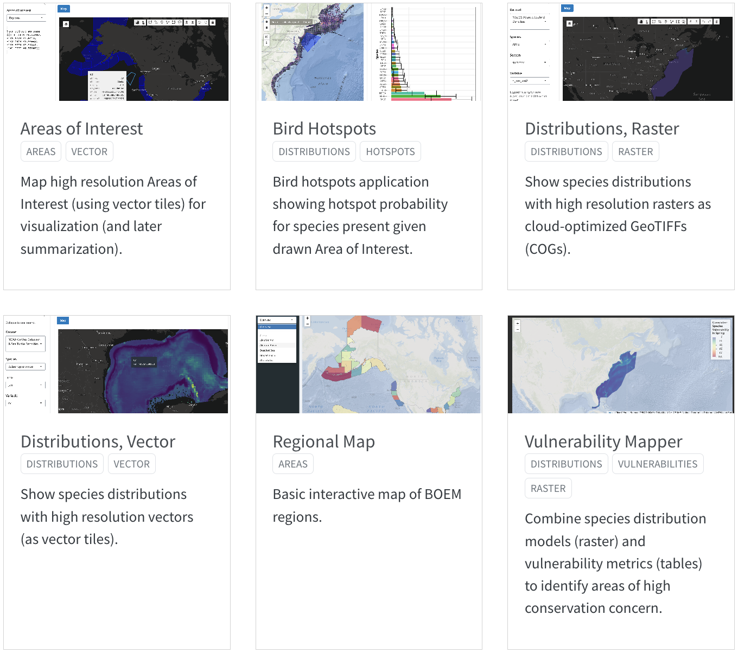

See also details of individual applications in the Appendix.

# 13. Docs

Technical documentation is principally in this book:

* [marinesensitivity.org/docs](https://marinesensitivity.org/workflows/)  
  the main documentation site
* [github.com/MarineSensitivity/docs](https://github.com/MarineSensitivity/workflows)  
  source code in the Github repository

But there are also some other self-documenting resources:

* [marinesensitivity.org/msens](https://marinesensitivity.org/faq/)  
  documented R functions

# 14. Summary

…

# References

Goodale, M. Wing, and Anita Milman. 2016. “Cumulative Adverse Effects of Offshore Wind Energy Development on Wildlife.” *Journal of Environmental Planning and Management* 0 (0): 1–21. <https://doi.org/10.1080/09640568.2014.973483>.

Ross, Pauline M., Elliot Scanes, Maria Byrne, Tracy D. Ainsworth, Jennifer M. Donelson, Shawna A. Foo, Pat Hutchings, Vengatesen Thiyagarajan, and Laura M. Parker. 2023. “Surviving the Anthropocene: The Resilience of Marine Animals to Climate Change.” In. CRC Press.

# Glossary

acclimatisation

the adjustment of an organism to environmental conditions in the field or environment rather than the laboratory without an adjustment in their genetics. Acclimatisation has been used to describe phenotypically plastic responses in natural conditions. Source: Ross et al. (2023).

adaptation

the evolutionary mechanism where natural selection of traits is genetically passed on, typically over many generations, to create an organism suited to the environment. Source: [rossRoss et al. (2023)

adaptive capacity

the capacity of the ecosystem or organism to improve and reorganise in response to stress such as climate change through phenotypic plasticity (acclimation, acclimatisation) or adaptation, distributional shifts, and rapid evolution of traits suited to new conditions. Source: Ross et al. (2023).

epigenetics

the modification of phenotype plasticity of an organism through altered gene expression without an alteration to the DNA sequence. ‘Epi’ means above the DNA and includes DNA methylation, modification of histones, and non-coding RNA. Source: Ross et al. (2023).

exposure

the magnitude of the change in the environment

fecundity

the maximum physiological potential reproductive output of an organism to produce offspring (reproductive output). This differs from fertility, which is the number of offspring born. Source: Ross et al. (2023)

MBON

Marine Biodiversity Observation Network; see <MarineBON.org>

resilience

the capacity of an ecosystem, society, or organism to absorb disturbance and reorganise while undergoing change so as to retain essentially the same function, structure, identity, and feedbacks. Resilience reflects the degree to which a complex adaptive system is determined by its capacity to reorganise and adapt in order to avoid being disturbed again. Source: Ross et al. (2023).

sensitivity

the magnitude of response to the change

stressor

the stimulus that causes stress to an organism

vulnerability

combination of exposure and sensitivity

# Areas of Interest

Map high resolution Areas of Interest (using vector tiles) for visualization (and later summarization).

* [website](https://shiny.marinesensitivity.org/aoi/)
* [code](https://github.com/MarineSensitivity/apps/tree/main/aoi)



# Bird Hotspots

Bird hotspots application showing hotspot probability for species present given drawn Area of Interest.

* [website](https://shiny.marinesensitivity.org/bird_hotspots/)
* [code](https://github.com/MarineSensitivity/apps/tree/main/bird_hotspots)



# Regional Map

Basic interactive map of BOEM regions.

* [website](https://shiny.marinesensitivity.org/map/)
* [code](https://github.com/MarineSensitivity/apps/tree/main/map)



# Distributions, Vector

Show species distributions with high resolution vectors (as vector tiles).

* [website](https://shiny.marinesensitivity.org/sdm/)
* [code](https://github.com/MarineSensitivity/apps/tree/main/sdm)



# Distributions, Raster

Show species distributions with high resolution rasters as cloud-optimized GeoTIFFs (COGs).

* [website](https://shiny.marinesensitivity.org/sdm-cog/)
* [code](https://github.com/MarineSensitivity/apps/tree/main/sdm-cog)



# Vulnerability Mapper

Combine species distribution models (raster) and vulnerability metrics (tables) to identify areas of high conservation concern.

* [website](https://shiny.marinesensitivity.org/vmap/)
* [code](https://github.com/MarineSensitivity/apps/tree/main/vmap)

